AI-Powered Predictive Analysis of Smartphone Market Trends Using Sentiment-Aware Ensemble Learning
Yash Singhal, Yash Khandelwal, Megha Kundi
Department of Computer Science and Engineering
Jaypee University of Engineering and Technology, Guna, India
231b405@juetguna.in, 231b401@juetguna.in, 231b187@juetguna.in

Table of Contents
Abstract
Keywords
I. Introduction
II. Literature Review
III. Methodology / Proposed System
IV. Implementation
V. Results and Discussion
VI. Advantages and Limitations
VII. Future Scope
VIII. Conclusion
References

Abstract
This paper presents an end-to-end AI-powered prediction system for analyzing and forecasting smartphone market trends from Flipkart customer reviews. The system was designed to solve a practical problem: e-commerce reviews contain valuable consumer sentiment, but the data is noisy, unevenly distributed, difficult to scrape continuously, and rarely converted into future-facing product intelligence. The proposed pipeline collects reviews for iPhone 15, iPhone 16, and iQOO Z10 using a fault-tolerant scraper with user-agent rotation, retry handling, checkpoint saving, backup CSV generation, and progress logs that allow scraping to resume after interruption or blocking. The collected data is cleaned through a conservative reviewer-name removal algorithm before sentiment modeling. Three complementary sentiment approaches are then evaluated: VADER for fast rule-based polarity, BERT for contextual language understanding, and a domain-specific word-cloud keyword proxy for interpretability. Their outputs are combined through hard voting, weighted soft voting, and bootstrap bagging to reduce single-model bias. Finally, the best sentiment signal is fused with linear trend projection and exponential moving average forecasting to predict next-month ratings. Experiments on 4,021 reviews show that BERT achieves 86.99% individual accuracy, soft voting improves balanced performance with 0.5424 macro-F1 and 0.5916 Pearson correlation, and bagging reduces RMSE to 0.8973. The final system predicts ratings of 4.477, 4.467, and 4.339 for iPhone 15, iPhone 16, and iQOO Z10 respectively, demonstrating that sentiment-aware ensemble forecasting can transform raw public reviews into reliable and interpretable market trend intelligence.

Keywords
Sentiment analysis, smartphone reviews, ensemble learning, BERT, VADER, market forecasting, exponential smoothing.

I. Introduction

A. Background
Smartphone markets move quickly because consumer expectations around camera quality, battery endurance, display performance, software stability, price, and after-sales experience change rapidly after launch. Public review platforms therefore contain a dense record of post-purchase perception. Unlike structured sales dashboards, review text captures why users reward or reject a device, including subtle concerns such as heating, charging behavior, network reception, and perceived value. Sentiment analysis and opinion mining have long been used to organize such subjective text [1], [2], but market-facing prediction requires an additional step: converting noisy and delayed consumer opinions into a forward-looking quantitative signal.
The project studied in this paper addresses that gap through a complete pipeline. It performs web scraping, data cleaning, sentiment modeling, ensemble aggregation, and next-month rating prediction. The central research premise is that recent review sentiment, when combined with historical rating trends, can act as a leading indicator of product trajectory.

B. Problem Statement
Existing review analytics workflows often rely on a single sentiment method or report only aggregate positive-negative ratios. Such summaries are useful for retrospective monitoring but inadequate for forecasting. Lexicon models are fast but may miss product-specific context; transformer models are accurate but computationally heavy and can be biased toward dominant classes; keyword models are interpretable but lose syntax and negation. A robust smartphone trend prediction system must therefore reconcile model diversity, class imbalance, noisy text, and short historical time series.
A second practical problem emerged during data collection. Public e-commerce pages are not designed as stable research APIs. During scraping, requests may fail because of temporary network issues, anti-bot behavior, repeated access from the same IP address, changed HTML classes, empty pages, or rate-limiting responses. Restarting a scraper from page one after every interruption wastes time, increases duplicate traffic, and can further increase blocking risk. Therefore, this project required not only a sentiment model but also a resilient data acquisition method that could pause, save, recover, and resume from the last known successful point.

C. Dataset Scope and Source Rationale
The study intentionally uses Flipkart review data rather than mixing reviews from multiple sources. Flipkart was selected because it is a major Indian e-commerce marketplace, the target products are actively reviewed there, and review pages provide the minimum fields required for supervised evaluation: star rating, review title, review body, and review date. The star rating is essential because it acts as the ground-truth label for positive, neutral, and negative sentiment mapping. Without that rating field, the project would require manual labeling or weak labels, which would reduce reproducibility.
Other sources such as Amazon, YouTube comments, social media posts, and general web forums were deliberately excluded from the first version. They have different schemas, different moderation policies, different levels of purchase verification, and different kinds of noise. Combining them too early would create a cross-platform normalization problem: a five-star product review, a short social media complaint, and a video comment do not carry the same signal. Using one platform kept the dataset internally consistent and allowed the project to focus on the core research question: whether cleaned review sentiment can improve next-month product rating forecasts.

D. Objectives
The objectives of this work are to design a reproducible pipeline for smartphone review collection and cleaning, compare multiple sentiment models against star-rating ground truth, construct ensemble models that balance accuracy and rating-scale error, and produce next-month product rating forecasts through a hybrid combination of sentiment and time-series signals.

II. Literature Review
Pang, Lee, and Vaithyanathan [3] established early supervised sentiment classification by applying machine learning methods to review polarity, showing that sentiment classification is more difficult than topic classification because subjective language is context-sensitive. Turney [4] demonstrated an unsupervised semantic orientation approach, using adjective and adverb phrases to classify reviews as recommended or not recommended. These works provide the conceptual basis for treating user reviews as predictive signals rather than simple text records.
Hu and Liu [5] moved sentiment analysis closer to product analytics by mining and summarizing customer reviews around product features. Their feature-based summarization is especially relevant to smartphones, where the same overall rating may arise from different factors such as camera quality, battery life, or delivery experience. Liu's broader survey [1] further systematized opinion mining tasks, including sentiment classification, target identification, and opinion summarization.
Hutto and Gilbert [6] introduced VADER, a parsimonious rule-based sentiment model designed for short informal text. Its practical strength lies in speed and human-readable scoring rules for punctuation, capitalization, degree modifiers, and negation. However, lexicon-based systems are limited when a review contains domain-specific phrases or indirect sentiment. Transformer models address this limitation. Vaswani et al. [7] introduced the self-attention architecture that enabled modern contextual language models, while Devlin et al. [8] proposed BERT, which learns bidirectional contextual representations and has become a strong baseline for text classification.
Forecasting literature provides the second foundation of this work. Gardner [9] reviewed exponential smoothing as a practical forecasting family that reacts to recent changes while retaining historical memory. Linear trend models remain interpretable and useful when long-term rating movement is approximately monotonic. Ensemble learning supplies the third foundation: Breiman's bagging [10] reduces model variance through bootstrap aggregation, and Friedman [11] showed how additive model combinations can improve predictive performance. In review analytics, these ideas motivate combining sentiment classifiers rather than selecting a single winner. Compared with the above works, the present system contributes an end-to-end implementation that joins review scraping, transformer and lexicon sentiment, ensemble correction, and next-month smartphone rating prediction in one reproducible pipeline.

III. Methodology / Proposed System

A. System Architecture
The proposed architecture follows a staged data-to-forecast design. The first layer acquires reviews from Flipkart product pages and stores rating, review text, reviewer name, and date fields in CSV format. The second layer performs cleaning, including conservative reviewer-name removal from the end of review strings. The third layer estimates sentiment through VADER, BERT, and a TF-IDF word-cloud proxy. The fourth layer aggregates model outputs through voting and bootstrap-based ensembles. The final layer combines the best sentiment signal with monthly rating trends to forecast the next-month average rating.
The project is organized as a reproducible seven-stage workspace. The folder `1_data_scrapping` stores separate Flipkart scrapers for iPhone 15, iPhone 16, and iQOO Z10. The folder `2_dataset_final_folder` contains both pre-cleaning backups and final cleaned datasets. The folder `3_sentimental_analysis` contains the comparative sentiment experiment, while `4_enemble_analysis` stores ensemble outputs, reliability plots, cumulative ratings, and model summaries. The folder `5_next_month` contains the forecasting script and final prediction artifacts. The folder `6_dashboard` turns the CSV and chart outputs into an interactive Dash dashboard, and `docs` records the technical reasoning behind data cleaning, sentiment analysis, ensembling, forecasting, and the mathematical walkthrough.
Table I. Project Artifact Map
Stage | Folder / File | Main Role | Output Produced
1 | 1_data_scrapping | Flipkart review extraction using Requests, BeautifulSoup, rotating user agents, retry logic, and checkpoint saving. | Raw review CSV files for each smartphone.
2 | 2_dataset_final_folder | Reviewer-name removal, text normalization, backup preservation, and final data preparation. | Cleaned CSVs used by all later scripts.
3 | 3_sentimental_analysis/YS | Comparison of VADER, BERT, and TF-IDF word-cloud sentiment models. | comparison_results_v2.csv, comparison_summary_v2.csv, confusion matrices.
4 | 4_enemble_analysis | Hard voting, soft voting, and bagging over base sentiment predictions. | ensemble_results_v2.csv, ensemble_summary_v2.csv, reliability and RMSE plots.
5 | 5_next_month | Hybrid forecasting from linear trend, exponential smoothing, and soft-voting sentiment. | next_month_prediction_v2.csv and trend charts.
6 | 6_dashboard | Interactive visualization of model metrics, forecast components, and time-series behavior. | Dash web dashboard.
7 | docs | Human-readable project documentation and mathematical walkthrough. | Design reports and implementation explanation.
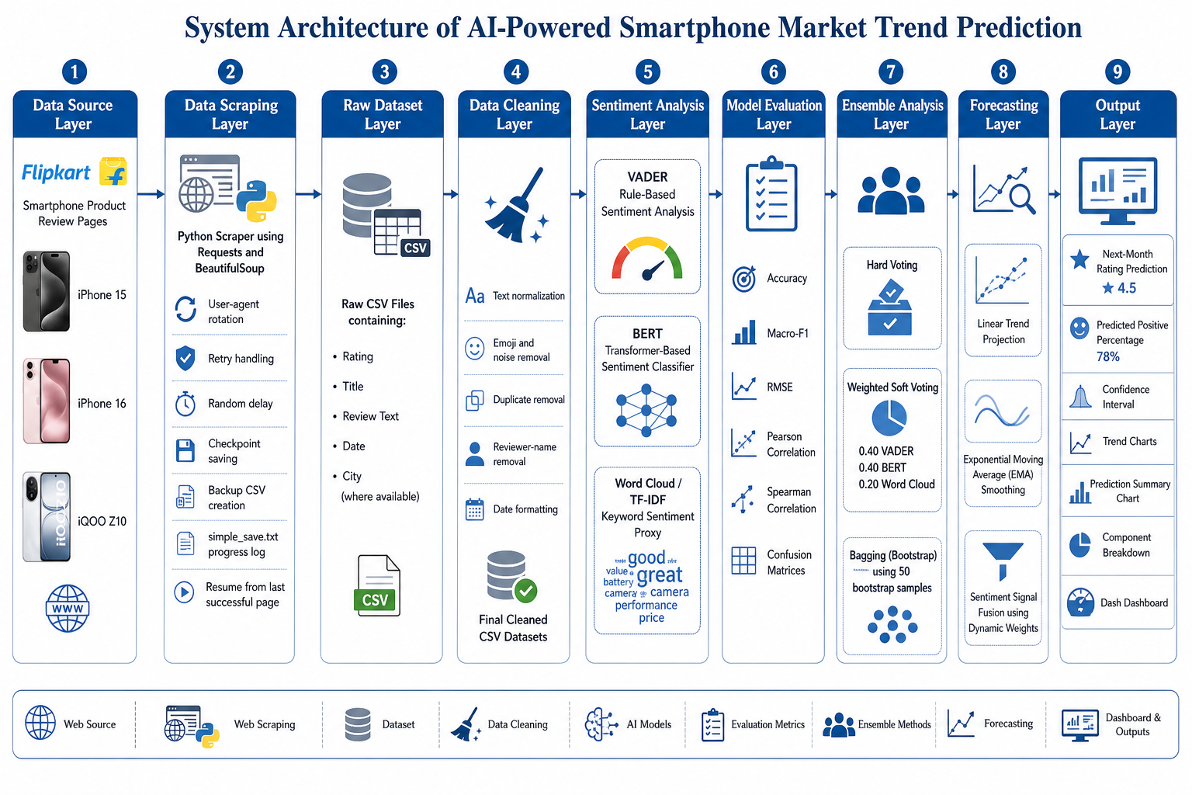
Figure 1: System Architecture

B. Algorithms and Models Used
VADER computes a compound polarity score using a sentiment lexicon and rule-based intensity modifiers. The BERT component uses a pretrained transformer sentiment classifier that maps review text into contextual token representations and returns class probabilities. The word-cloud category proxy derives positive and negative keyword weights from TF-IDF scores, producing an interpretable domain-specific baseline. Hard voting uses the majority sentiment label across base models; soft voting averages normalized score signals; and bagging estimates rating-level sentiment through repeated bootstrap aggregation. For forecasting, the system uses linear regression on monthly mean ratings, single exponential smoothing, and a recent soft-voting sentiment signal.
The final prediction is computed as Final Rating = w1L + w2E + w3S, where L is the linear trend forecast, E is the exponential smoothing forecast, and S is the recent sentiment forecast. The weights are dynamic. Devices with six or more historical months use 0.40, 0.35, and 0.25 for linear trend, smoothing, and sentiment respectively; devices with three to five months use 0.30, 0.35, and 0.35; devices with fewer than three months depend more heavily on recent sentiment.
The scraper layer uses several safeguards because e-commerce review pages are semi-structured and can change over time. Each request is made through a persistent session for connection reuse. Browser headers are rotated to reduce blocking, and randomized delays are inserted between requests. A page is parsed by scanning likely review-card containers and then falling back to generic div-pattern extraction. Noise terms such as certified buyer labels, report-abuse links, storage/color markers, and pagination text are filtered before a row is accepted. Deduplication is performed using a composite key built from rating, title prefix, and review-text prefix. The iPhone 16 and iQOO Z10 scrapers additionally extract or infer review month values and implement resume logic through progress files.
The need for this design came from practical scraping failures. When many pages are requested sequentially, the host may stop returning normal review cards, the network may time out, or the scraper may be interrupted manually. The scripts therefore avoid treating scraping as one long all-or-nothing operation. They save periodically after a small batch of pages, maintain a `simple_save.txt` log with timestamps and page-level counts, preserve backup CSV files before rewriting, and track the last successful page. The iQOO Z10 scraper additionally writes `last_page.txt` with a parseable `LAST_SUCCESSFUL_PAGE` value. This means that after a stop, the scraper can continue from the next page or the nearest safe checkpoint instead of starting again from the first page. In practical terms, this is what made it possible to keep collecting more reviews even when IP-based blocking, empty responses, or runtime interruptions occurred.
The checkpoint size is intentionally small. In the code, the scraper saves every five pages rather than waiting until the end of the product crawl. Depending on the number of reviews extracted per page, this behaves like a small review batch checkpoint. The project description often refers to this idea as saving after a group of reviews; the exact implementation is page-based because page count is easier to track reliably during crawling. Each checkpoint writes new rows to CSV, removes duplicates, clears in-memory rows, and logs the current state. This reduces memory usage, protects already collected reviews, and prevents duplicate records after resuming.
The cleaning layer is intentionally conservative. The `clean_names.py` script does not simply remove the last two words of every review. Instead, it checks whether the trailing two- or three-token block looks like a reviewer name. A candidate name token must be alphabetic, lowercase after normalization, between 2 and 20 characters, and absent from a large English-word blocklist. For two-token names, the preceding token must be either punctuation-terminated or a recognized content word. For three-token names, the preceding token must end with punctuation. This design protects valid endings such as 'very good', 'this phone', and 'best part' while removing examples such as 'sarath kumar' or 'bijaya mohanty'.
Table II. Dataset Preparation and Current Cleaned Snapshot
Device | Rows Before Cleaning | Rows After Current Cleaning | Text Rows Modified | Current Rating Distribution
iPhone 15 | 3315 | 3315 | 456 | 1:143, 2:49, 3:105, 4:414, 5:2604
iPhone 16 | 719 | 719 | 99 | 1:28, 2:7, 3:22, 4:86, 5:576
iQOO Z10 | 57 | 46 | 46 | 1:4, 2:3, 3:1, 4:8, 5:30

C. Workflow Explanation
The workflow begins by extracting raw reviews and converting them into structured tabular records. After cleaning, each review is mapped to a ground-truth sentiment label using its star rating: one or two stars are negative, three stars are neutral, and four or five stars are positive. The three sentiment methods are evaluated using accuracy, macro-F1, RMSE, Pearson correlation, and Spearman correlation. Ensemble outputs are then measured using the same metrics to identify the best signal for forecasting. Finally, review dates are grouped by month to form time series for each device, and the three forecasting signals are combined into the next-month rating prediction.
The paper distinguishes between the current cleaned dataset snapshot and the archived model-output dataset used for the reported experiment. The saved comparison and ensemble result files contain 4,021 usable review rows: 3,245 for iPhone 15, 719 for iPhone 16, and 57 for iQOO Z10. The current cleaned CSV snapshot contains a later iQOO Z10 file with 46 rows after additional cleaning. Therefore, the performance metrics, plots, cumulative ratings, and forecast tables are cited from the archived experiment artifacts so that the reported values match `comparison_results_v2.csv`, `ensemble_results_v2.csv`, `ensemble_summary_v2.csv`, `cumulative_ratings_v2.csv`, and `next_month_prediction_v2.csv`.
At the individual-review level, the system stores both discrete sentiment labels and continuous predicted ratings. For VADER, the compound polarity score is linearly rescaled from [-1, 1] to [1, 5] by the transformation rating = (compound x 2) + 3. For BERT, the implemented DistilBERT SST-2 pipeline returns a positive/negative sentiment decision; the script converts this output into a positive probability and maps it to the rating scale using rating = 1 + 4 x P(positive). Values near 1 indicate strongly negative text, while values near 5 indicate strongly positive text. For the word-cloud proxy, the model starts from a neutral base score and adjusts the value upward or downward according to domain keywords learned from positive and negative review groups.
The choice of the three sentiment models was also deliberate. VADER was included because it is fast, transparent, and robust for short informal text, making it suitable for quick baselines and large batches. BERT was included because transformer encoders understand context, contrast, and indirect sentiment better than word lists. The word-cloud proxy was included because it is domain-specific and interpretable: it makes visible which product-review terms are contributing to the score. These three models have different failure modes, which is precisely why they are useful together.
The ensemble stage then resolves disagreement between models. Hard voting converts each continuous prediction into a class and selects the majority label. Soft voting preserves numeric information by averaging the continuous ratings, which prevents a score such as 3.95 from being treated the same as a clearly neutral 3.00. Bagging creates 50 bootstrap samples with replacement and averages repeated soft-voting estimates, reducing sensitivity to unusual reviews or small sample perturbations. The forecasting stage selects soft voting as the primary sentiment signal because it offers the best balance of macro-F1 and correlation with actual ratings.
Soft voting in the implementation is not an unweighted average. When BERT outputs are available, the script combines the rating-like scores using 0.40 weight for VADER, 0.40 for BERT, and 0.20 for the word-cloud proxy. This preserves the strength of the two more general sentiment engines while still retaining a contribution from the domain keyword model. If BERT is unavailable, the fallback uses 0.60 VADER and 0.40 word-cloud weighting. The soft-vote score is then mapped back to sentiment classes using rating thresholds: scores at or above 3.75 are positive, scores at or below 2.25 are negative, and the middle region is neutral.
Bagging is used to examine stability. The script creates 50 bootstrap samples, each containing approximately 80% of the dataset sampled with replacement. Since the base models are deterministic after their predictions are generated, bagging does not retrain a new neural network; instead, it measures how stable the ensemble rating estimate remains under resampled review populations. The resulting `bagging_pred_std` field records per-review uncertainty. Lower standard deviation indicates that the prediction is less sensitive to which reviews happened to be sampled.

IV. Implementation

A. Tools and Technologies
The system is implemented in Python. Pandas and NumPy support dataset manipulation, monthly aggregation, and numeric computation. Scikit-learn and SciPy are used for classification metrics, RMSE, and correlation analysis. The vaderSentiment package provides VADER scoring, while Hugging Face Transformers and PyTorch support the BERT sentiment model. Matplotlib, Seaborn, Plotly, Dash, and wordcloud support visualization, dashboarding, and interpretable keyword analysis.

B. Step-by-Step Working
First, the scraper collects review pages using browser-like request headers, throttling, retry logic, and progress logging. Second, cleaning scripts preserve the review content while removing trailing reviewer names that would otherwise distort sentiment tokens. Third, the sentiment comparison script processes the cleaned data and exports per-review predictions and aggregate metrics. Fourth, the ensemble script imports those predictions, computes hard voting, soft voting, and bagging outputs, and generates reliability plots. Fifth, the forecasting script reads the cleaned product files and ensemble results, derives monthly signals, applies dynamic weights, and exports forecast tables and charts. The dashboard folder then serves the generated summaries for interactive inspection.
The data acquisition scripts differ slightly by device because the available Flipkart page structures and review metadata vary. The iPhone 15 scraper focuses on rating, title, and review text extraction and saves progress every five pages. The iPhone 16 scraper extends this logic by extracting review dates from explicit month-year strings or relative expressions such as months ago, and it also attempts city extraction before removing location text from the final review content. The iQOO Z10 scraper implements a two-level parsing strategy: it first searches common Flipkart review-card classes and data-review-id attributes, then falls back to generic text segmentation if the structured parse fails. It also records the last successful page in `last_page.txt` and estimates a resume page from existing CSV length.
During validation, each candidate review must satisfy length, noise, and uniqueness constraints. Titles shorter than four characters, numeric-only titles, page navigation fragments, storage/color labels, and platform boilerplate are discarded. Review text is limited to a safe length range so that extremely short fragments and large page-level text blocks are not treated as genuine reviews. Before each CSV write, the script creates a backup where applicable, appends new rows, removes duplicates on title and review text, and writes the consolidated dataset back to disk.
The progress-management design is one of the most important implementation choices. The scraper records every major event with a timestamp: starting page, pages with successful review counts, pages with no reviews, network retry messages, checkpoint saves, interruption events, and final totals. This text log is not only for debugging; it is a recovery record. If the program stops because the internet connection fails, the website blocks repeated requests, or the user interrupts execution, the log shows the last page that produced usable reviews. The iPhone 16 scraper parses this progress file to calculate a resume page based on the nearest previous multiple-of-five checkpoint. The iQOO Z10 scraper combines CSV length estimation with `last_page.txt`, choosing the safer higher page number before continuing. This avoided repeated scraping from the beginning and reduced load on the source website.
The project also had to handle changing page structures. Flipkart review cards do not always expose clean semantic selectors, and different products may render review text differently. The iQOO Z10 scraper therefore tries structured selectors such as review-card attributes first, then falls back to a generic parse that separates page text by delimiters and validates rating-title-review patterns. The iPhone scrapers scan div text line-by-line and reject blocks containing page-level summary phrases such as ratings and reviews or user reviews sorted. This hybrid parsing strategy is less elegant than an official API, but it is practical for real scraped web data.

E. Why EMA and Weighted Forecasting Were Used
Exponential moving average, implemented as single exponential smoothing, was chosen because smartphone review streams are time-dependent but not large enough for heavy time-series models. A product can receive sudden negative sentiment after a software update, price change, delivery issue, or competitor launch. A simple historical mean would react too slowly, while a model that only uses the latest month would overreact to temporary noise. EMA solves this by blending the latest observation with the previous smoothed value. The smoothing factor alpha controls responsiveness: this project uses alpha = 0.30 when at least eight monthly observations exist and alpha = 0.45 when the history is shorter. Thus, mature devices receive steadier forecasts, while newer devices respond more strongly to recent movement.
The final forecast is weighted instead of purely model-driven because each signal answers a different question. Linear trend answers whether the product has been gradually improving or declining. EMA answers what the recent momentum looks like. Sentiment answers what the latest review text says beyond the star rating. If a device has six or more months of history, the project gives more weight to trend and smoothing: 0.40 linear, 0.35 EMA, and 0.25 sentiment. If the device has three to five months, the weights are 0.30, 0.35, and 0.35 because recent sentiment still matters strongly. With fewer than three months, sentiment becomes the dominant signal because the time series is too short to support a reliable trend.
The sentiment comparison script evaluates each method at two levels. At the review level, it stores text, ground-truth rating, predicted sentiment label, and predicted rating-like score. At the summary level, it computes accuracy, macro-F1, RMSE, Pearson correlation, and Spearman correlation. Accuracy is retained for readability, but macro-F1 is emphasized because the dataset contains many more positive reviews than neutral or negative reviews. RMSE is included because the final task is rating prediction rather than only class prediction.
Table III. Key Mathematical Operations Used in the Pipeline
Operation | Formula / Rule | Purpose in Project
VADER rating conversion | rating = (compound x 2) + 3 | Maps polarity from [-1, 1] to the 1-5 product-rating scale.
BERT rating conversion | rating = 1 + 4 x P(positive) | Maps the DistilBERT SST-2 positive probability to the 1-5 rating scale.
Hard voting | class = majority(base model labels) | Produces an interpretable class decision from three model votes.
Soft voting | rating = 0.40 VADER + 0.40 BERT + 0.20 Word Cloud | Preserves confidence while weighting the two general sentiment engines more strongly.
Bagging | 50 bootstrap samples; sample fraction = 0.80 | Measures stability and reduces sensitivity to resampled review populations.
Linear trend | y = mx + c | Projects long-term monthly rating movement into the target month.
Exponential smoothing | S_t = alpha y_t + (1-alpha)S_(t-1) | Captures recent momentum without ignoring historical behavior.
Final forecast | F = w1L + w2E + w3S | Combines trend, smoothing, and sentiment into the next-month rating.

C. Dashboard Implementation
The dashboard is implemented with Dash and Plotly. It loads `comparison_summary_v2.csv`, `ensemble_summary_v2.csv`, `ensemble_results_v2.csv`, and `next_month_prediction_v2.csv` directly from the project folders, then rebuilds monthly time-series values from the cleaned product datasets. A month parser converts strings such as Jan 2026 into timestamps. The first dashboard view displays the final forecast breakdown for a selected device, showing each component value, its assigned weight, and its contribution to the final prediction. The second view overlays actual monthly ratings, soft-voting monthly predictions, and the next-month forecast with confidence interval bounds. This makes the dashboard a verification surface, not only a presentation layer.

D. Reproducibility Notes
All major outputs are stored as CSV or PNG artifacts, which makes the pipeline auditable. Intermediate files such as `comparison_results_v2.csv` and `ensemble_results_v2.csv` preserve per-review predictions, allowing any aggregate metric to be recomputed. Summary files provide compact tables for reporting, while generated plots support visual inspection of confusion matrices, metric comparisons, reliability behavior, cumulative ratings, trend lines, and component contributions. The separation of raw, cleaned, model, ensemble, forecast, and dashboard folders also makes it possible to rerun one stage without overwriting the full project.
The project outputs are intentionally redundant. Per-review result files preserve the detailed prediction trail, summary CSVs preserve compact metrics, and PNG plots preserve visual evidence. This is useful in academic reporting because a table alone does not reveal class imbalance or reliability behavior. Confusion matrices show which classes are being confused; correlation plots show whether predicted ratings move with actual ratings; reliability plots show whether bootstrap predictions are stable; and component-breakdown plots show how much each forecast signal contributes to the final value.
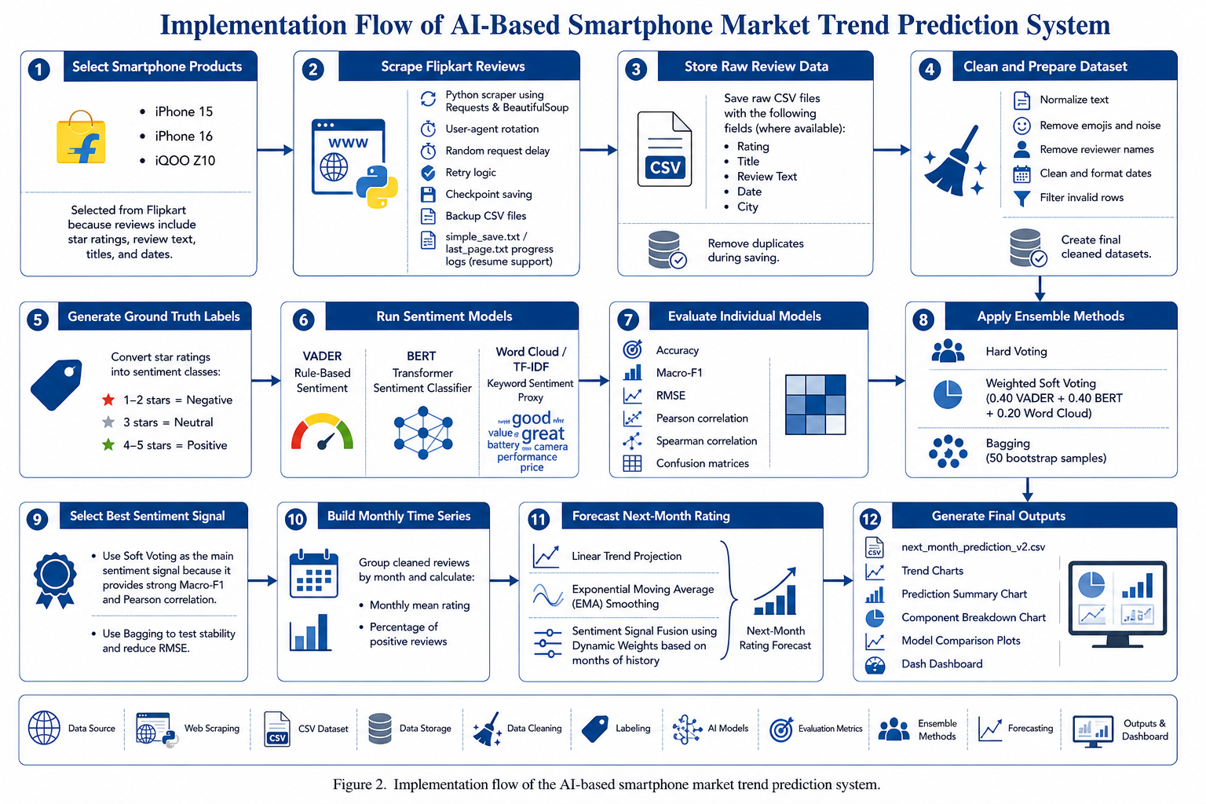
Figure 2: Implementation Flow

V. Results and Discussion

A. Performance Analysis
The experimental dataset contains 4,021 reviews: 3,245 for iPhone 15, 719 for iPhone 16, and 57 for iQOO Z10. The review distribution is strongly positive, with actual positive-rate values of 91.2%, 92.1%, and 86.0% respectively. This imbalance explains why accuracy alone is insufficient. BERT achieves the strongest single-model accuracy, but macro-F1 and RMSE reveal that simpler and ensemble methods handle minority classes and rating-scale error more effectively.
The sentiment comparison produces an important practical insight. BERT reaches 0.8699 accuracy overall, which confirms the value of contextual transformer representations for common review polarity. However, its macro-F1 of 0.4758 is lower than the word-cloud proxy's 0.5094 and VADER's 0.5000, indicating that the high accuracy is partly driven by the dominant positive class. The word-cloud proxy obtains the lowest single-model RMSE of 1.1245 because domain-specific keywords such as camera, battery, amazing, bad, heating, and value align closely with rating-scale movement. This explains why the project did not simply adopt BERT as the final model.
Table IV. Overall Sentiment Model Comparison
Method | N | Accuracy | Macro-F1 | RMSE | Pearson r | Spearman rho
VADER | 4021 | 0.7690 | 0.5000 | 1.1606 | 0.4529 | 0.3018
BERT | 4021 | 0.8699 | 0.4758 | 1.2094 | 0.5423 | 0.3520
Word Cloud | 4021 | 0.7120 | 0.5094 | 1.1245 | 0.4798 | 0.3219
Hard Voting | 4021 | 0.7819 | 0.5389 | 1.0533 | 0.5523 | 0.3703
Soft Voting | 4021 | 0.8386 | 0.5424 | 0.9599 | 0.5916 | 0.3565
Bagging | 4021 | 0.8374 | 0.3776 | 0.8973 | 0.5900 | 0.3560
Soft voting provides the most balanced sentiment classifier, achieving the highest macro-F1 and Pearson correlation. Bagging achieves the lowest RMSE, indicating the best rating-scale proximity. The result supports the central design choice of preserving model diversity rather than selecting a single sentiment classifier.
The ensemble results show that hard voting improves macro-F1 to 0.5389 by reducing isolated model mistakes, but it still discards score intensity. Soft voting improves Pearson correlation to 0.5916 and macro-F1 to 0.5424 because it uses the continuous strength of each base model's prediction. Bagging produces the lowest RMSE of 0.8973, which means its predictions are closest to actual star ratings on average. The final system therefore treats soft voting as the most balanced live sentiment signal and bagging as evidence that bootstrap aggregation can stabilize the rating-scale estimate.
Table V. Next-Month Forecast Results
Device | Target Month | History | Last Rating | Linear | Exp. Smooth | Sentiment | Predicted
iPhone 16 | Feb 2026 | 14 months | 4.455 | 4.530 | 4.615 | 4.160 | 4.467
iPhone 15 | Feb 2025 | 17 months | 4.633 | 4.566 | 4.618 | 4.139 | 4.477
iQOO Z10 | Mar 2026 | 3 months | 4.643 | 4.606 | 4.445 | 4.005 | 4.339
The forecast values remain positive for all products but reveal meaningful differences. iPhone 15 and iPhone 16 show stable high-rating trajectories because their long historical records support stronger trend and smoothing weights. iQOO Z10, with only three months of history, is more sensitive to its recent sentiment signal and therefore receives a lower prediction despite a strong last observed rating.
Table VI. Device-Level Cumulative Rating Summary
Device | Reviews | Actual Mean | Actual Positive % | VADER Mean | BERT Mean | Word-Cloud Mean
iPhone 16 | 719 | 4.634 | 92.1 | 3.942 | 4.247 | 4.421
iPhone 15 | 3245 | 4.598 | 91.2 | 3.840 | 4.398 | 4.219
iQOO Z10 | 57 | 4.316 | 86.0 | 4.057 | 3.808 | 4.296
The device-level table highlights another design issue: mean rating and positive percentage are high for every device, but the models estimate different absolute rating levels. VADER is conservative for the iPhone devices, BERT is relatively strong for iPhone 15 and iPhone 16, and the word-cloud proxy closely tracks iQOO Z10 despite the smaller sample. These differences justify ensemble construction because each model captures a different view of the same consumer-opinion signal.
[Insert Figure 3 here: Output Results]
Figure 3: Output Results

B. Discussion
The findings show that market sentiment forecasting benefits from a separation between interpretation and prediction. BERT is highly effective at broad polarity recognition, but the ensemble methods are more useful when the output must behave like a rating-scale forecast. The system's dynamic weighting strategy also reduces overreaction: mature products are guided more by history, while newer products are guided more by recent opinion. This design is particularly suitable for e-commerce markets where review volume, launch recency, and class imbalance differ across products.
The observed forecasting behavior also matches the design intention. The iPhone 15 and iPhone 16 have long histories, so the final predictions are controlled mainly by trend and EMA. Their recent sentiment signal is lower than their last observed rating, which prevents the forecast from simply copying the high latest rating. The iQOO Z10 has only three months of history, so sentiment receives a larger weight. As a result, its forecast drops more sharply, which is appropriate for a product where a small number of recent reviews can materially change the estimated trajectory.
From a research perspective, the main result is not only that one method scored better than another. The project shows that the data pipeline itself is part of the model. If scraping is interrupted and data is duplicated, if names remain attached to review text, if star ratings are mapped poorly, or if class imbalance is ignored, the final forecast will be unreliable regardless of the machine-learning algorithm. The system therefore treats data acquisition, cleaning, sentiment modeling, ensembling, and forecasting as a single chain where every stage must preserve signal quality.

VI. Advantages and Limitations
The proposed system offers several advantages. It is end-to-end, reproducible, and interpretable at both model and business levels. It compares heterogeneous sentiment models, uses ensemble learning to reduce single-model bias, and produces concrete next-month rating forecasts instead of only descriptive dashboards. The inclusion of VADER and TF-IDF baselines also makes the system computationally flexible, while BERT provides contextual understanding where review text is linguistically complex.
A major practical advantage is fault tolerance during scraping. Since reviews are saved at checkpoints and backed up before rewriting, the system does not lose all work when crawling stops. The progress log provides traceability, the resume mechanism reduces duplicate traffic, and duplicate-key filtering prevents repeated rows from contaminating the dataset. These engineering details are important because most academic prototypes describe scraping as a single step, whereas real scraping often fails repeatedly due to IP throttling, unstable HTML, or connection limits.
Another advantage is methodological balance. VADER supplies speed and interpretability, BERT supplies contextual understanding, the word-cloud proxy supplies domain visibility, soft voting supplies balanced prediction, bagging supplies robustness testing, and EMA supplies recent-momentum awareness. The final forecast is therefore not dependent on one black-box model or one fragile statistic.
The limitations are equally important. The dataset is sourced from one e-commerce platform, so platform-specific reviewer behavior may affect generalization. Star ratings are treated as ground truth, although users sometimes provide ratings that conflict with review text. The iQOO Z10 dataset is much smaller than the iPhone datasets, which increases forecast uncertainty. The BERT component is computationally heavier than rule-based methods, and the current model does not explicitly extract product aspects such as camera, battery, display, or service quality.
The single-platform choice is a limitation but also a controlled experimental decision. Flipkart reviews represent an Indian e-commerce context and may not generalize to global buyer behavior, offline retail sentiment, or social media discussion. In addition, scraped pages may omit reviews hidden behind dynamic rendering, pagination changes, or anti-bot responses. The confidence intervals in the current forecasting script are heuristic rather than fully probabilistic. Finally, BERT was used as a pretrained sentiment pipeline rather than a smartphone-specific fine-tuned model, so it may misread domain language such as heating, lag, dynamic island, charging, or value for money.

VII. Future Scope
Future work can extend the system in five directions. First, aspect-based sentiment analysis can be added to separate camera, battery, display, performance, and service-related sentiment. Second, review data can be collected from multiple platforms to reduce platform bias. Third, transformer models can be fine-tuned on smartphone-specific review data to improve minority-class recall. Fourth, probabilistic forecasting can replace fixed confidence intervals with calibrated uncertainty estimates. Fifth, the dashboard can be expanded into a decision-support system that alerts analysts when recent sentiment deviates materially from historical trend.
A future version can also add multi-source ingestion after a stronger normalization layer is built. Amazon, official brand stores, YouTube reviews, Reddit discussions, and social media posts can be added as separate channels rather than merged directly. Each channel should have its own trust score, schema, language filter, duplicate-removal logic, and sentiment calibration. This would allow the system to compare verified-purchase sentiment with broader public opinion while avoiding the confusion that comes from mixing fundamentally different text sources.
The scraping layer can be improved by adding proxy rotation, adaptive delay scheduling, browser automation for pages that render reviews dynamically, and explicit HTTP-status logging. The modeling layer can be improved by fine-tuning a transformer on the collected smartphone reviews and by training an aspect-based classifier. The forecasting layer can be improved by backtesting predictions month by month, estimating calibrated prediction intervals, and comparing EMA against ARIMA, Prophet-style decompositions, LSTM models, and gradient-boosted regressors.

VIII. Conclusion
This paper presented an IEEE-style study of an AI-powered smartphone market prediction system that converts public review text into next-month rating forecasts. The system integrates scraping, cleaning, sentiment classification, ensemble learning, and hybrid time-series forecasting. Results on 4,021 reviews show that no single sentiment model dominates all criteria: BERT provides the highest baseline accuracy, soft voting gives the strongest balanced classification and rating correlation, and bagging minimizes RMSE. By combining sentiment with linear and exponential trend signals, the system generates realistic product-level forecasts and demonstrates the practical value of sentiment-aware ensemble learning for market intelligence.

References
[1] B. Liu, Sentiment Analysis and Opinion Mining. San Rafael, CA, USA: Morgan & Claypool, 2012.
[2] W. Medhat, A. Hassan, and H. Korashy, "Sentiment analysis algorithms and applications: A survey," Ain Shams Engineering Journal, vol. 5, no. 4, pp. 1093-1113, 2014.
[3] B. Pang, L. Lee, and S. Vaithyanathan, "Thumbs up? Sentiment classification using machine learning techniques," in Proc. Conf. Empirical Methods in Natural Language Processing, 2002, pp. 79-86.
[4] P. D. Turney, "Thumbs up or thumbs down? Semantic orientation applied to unsupervised classification of reviews," in Proc. 40th Annu. Meeting Assoc. Comput. Linguistics, 2002, pp. 417-424.
[5] M. Hu and B. Liu, "Mining and summarizing customer reviews," in Proc. 10th ACM SIGKDD Int. Conf. Knowledge Discovery and Data Mining, 2004, pp. 168-177.
[6] C. J. Hutto and E. Gilbert, "VADER: A parsimonious rule-based model for sentiment analysis of social media text," in Proc. Int. AAAI Conf. Web and Social Media, vol. 8, no. 1, 2014, pp. 216-225.
[7] A. Vaswani et al., "Attention is all you need," in Advances in Neural Information Processing Systems, vol. 30, 2017, pp. 5998-6008.
[8] J. Devlin, M.-W. Chang, K. Lee, and K. Toutanova, "BERT: Pre-training of deep bidirectional transformers for language understanding," in Proc. NAACL-HLT, 2019, pp. 4171-4186.
[9] E. S. Gardner, Jr., "Exponential smoothing: The state of the art," Journal of Forecasting, vol. 4, no. 1, pp. 1-28, 1985.
[10] L. Breiman, "Bagging predictors," Machine Learning, vol. 24, no. 2, pp. 123-140, 1996.
[11] J. H. Friedman, "Greedy function approximation: A gradient boosting machine," Annals of Statistics, vol. 29, no. 5, pp. 1189-1232, 2001.
[12] S. Hochreiter and J. Schmidhuber, "Long short-term memory," Neural Computation, vol. 9, no. 8, pp. 1735-1780, 1997.
[13] A. S. Weigend, Time Series Prediction: Forecasting the Future and Understanding the Past. Reading, MA, USA: Addison-Wesley, 1994.
[14] T. G. Dietterich, "Ensemble methods in machine learning," in Multiple Classifier Systems, Berlin, Germany: Springer, 2000, pp. 1-15.
[15] M. Taboada, J. Brooke, M. Tofiloski, K. Voll, and M. Stede, "Lexicon-based methods for sentiment analysis," Computational Linguistics, vol. 37, no. 2, pp. 267-307, 2011.

